**Software Requirements Specification**

**1.Abstract:**

**2. Objective:**

**3. Scope:**

**4. Introduction:**

**5.Functional Requirements:**

**5.1 User Registration:**

**5.2 Product Catalog Management:**

**5.3 Shopping Cart:**

**5.4 Order Management:**

**5.5Payment Processing:**

**5.6 User Account Management:**

**5.7 Try-On Experience:**

**5.8 Furniture Placement and Home Decor:**

**5.9 Customer Support:6. Non-functional Requirements**

**7. Design:**

**8. Flowchart:**

**9. Use case:**

**10. Class Diagram:**

**11. Sequence Diagram:**

**12. Test Case:**

1

**1.Abstract:**

The Online Shopping Management System presents an overview of a sophisticated platform designed to streamline and optimize the operations of online retail businesses. This system encompasses a range of functionalities aimed at enhancing efficiency, improving customer experience, and driving business growth in the competitive e-commerce landscape. key components of the Online Shopping Management System include inventory management, order processing, customer relationship management, and analytics-driven decision-making. The system integrates secure payment gateways, robust data protection measures, and seamless user interfaces to ensure a safe and convenient shopping experience for customers. The system incorporates features such as product catalogue management, promotional campaigns, and real-time inventory updates to facilitate effective marketing strategies and boost sales. It also emphasizes the importance of responsive customer support, personalized recommendations, and efficient logistics management to build customer loyalty and satisfaction. By leveraging advanced technologies like artificial intelligence, machine learning, and data analytics, the Online Shopping Management System enables businesses to gain valuable insights into consumer behaviour, optimize inventory levels, and adapt to market trends swiftly. These abstract highlights the significance of adopting a holistic approach to online shopping management, focusing on operational excellence, customer-centricity, and continuous innovation for sustained success in the digital retail ecosystem.

**2. Objective:**

The objective of an online shopping management system is to create a comprehensive and efficient platform that enhances the entire shopping experience. This includes features such as streamlined inventory management to ensure accurate stock levels, a user-friendly interface with easy navigation and secure checkout processes, automated order processing and fulfillment for quick and accurate deliveries, personalized product recommendations to enhance customer satisfaction, integrated payment gateways for smooth transactions, robust analytics and reporting capabilities for informed decision-making, mobile compatibility for accessibility across devices, stringent security measures to protect customer data, scalability to accommodate business growth, and effective customer support channels for prompt assistance and feedback collection. These objectives collectively aim to optimize operations, improve customer satisfaction, and drive business success in the online retail industry.

**3. Scope:**

The Online Shopping Management System encompasses a wide range of functionalities and features aimed at optimizing the operations of an online retail business.

This System is comprehensive, covering all essential aspects of managing an online retail business efficiently and effectively. It aims to provide a seamless and satisfying shopping experience for customers while optimizing business processes and driving growth.

**4. Introduction:**

Online Shopping Management System sets the stage for understanding the significance and scope of implementing a robust platform for managing online retail operations. In today's digital age, the e-commerce landscape is rapidly evolving, with businesses striving to meet the growing demands and expectations of online shoppers. An efficient and well-structured Online Shopping Management System is essential to streamline processes, enhance customer experience, and drive business growth in this competitive environment. It highlights the challenges faced by online retailers, such as inventory management, order processing, customer relationship management, and data security. These challenges underscore the need for a comprehensive system that integrates various functionalities to ensure seamless operations and customer satisfaction. This includes increased efficiency, reduced operational costs, improved decision-making through data analytics, and scalability to accommodate business growth. It also acknowledges the role of emerging technologies like artificial intelligence, machine learning, and blockchain in transforming the e-commerce landscape and enhancing the capabilities of online shopping platforms.

**5. Functional Requirements:**

**5.1 User Registration:**

Allow users to register with the system by providing basic information, Implement authentication mechanisms such as username/password, email verification, or social media login and It’s Provides options for users to reset their passwords securely.

**2**

**5.2 Product Catalog Management:**

Admin panel to add, edit, and delete products with details like name, description, price, quantity, categories, and images and it’s Enables users to browse and search products based on various criteria like category, price range, brand, etc. Display product availability status (in stock/out of stock) to users.

**5.3 Shopping Cart:**

Allow users to add products to their shopping cart, update quantities, and remove items and calculate the total price including taxes, shipping fees, and discounts, save cart contents for registered users to retrieve later.

**5.4 Order Management:**

Enable users to place orders securely with options for multiple shipping addresses and payment methods (credit/debit card, PayPal, etc.). Generate order confirmation emails with order details and tracking information. Allow users to view their order history, track shipments, and initiate returns if applicable.

**5.5Payment Processing:**

Integrate a secure payment gateway to process transactions securely. Support multiple currencies and provide real-time currency conversion if necessary. Handle payment failures, refunds, and cancellations appropriately.

**5.6 User Account Management:**

Allow users to manage their profiles, update personal information, and manage communication preferences. Provide options for users to save favourite products, create Wishlist’s, and receive personalized recommendations.

**5.7 Try-On Experience:**

Provide AR try-on features for fashion and accessories, allowing users to virtually try on clothing, eyewear, jewellery, etc. In-corporate body tracking and sizing algorithms to ensure accurate virtual fittings and recommendations.

**5.8 Customer Support:**

Offer a help desk or ticketing system for customer inquiries, complaints, and support requests. Provide live chat support or chatbots for real-time assistance during shopping.

**6. Non-functional Requirements**

**6.1 Scalability:**

The system should scale horizontally or vertically to accommodate increased user traffic during peak periods (e.g., sales events, holidays) without downtime or performance issues.

**6.2 Data Encryption:**

User data, including personal information, payment details, and order history, should be encrypted during transmission and storage to protect against unauthorized access.

**6.3 Authentication and Authorization:**

Implement secure authentication mechanisms (e.g., username/password, multi-factor authentication) and role-based access control (RBAC) to ensure that users can only access authorized functionalities.

**6.4 Data Backup and Recovery:**

Regularly back up data and implement robust backup and recovery procedures to prevent data loss in case of system failures or security breaches.

**6.5 User Interface (UI) Design:**

Design an intuitive and user-friendly UI with clear navigation, consistent layouts, and informative feedback messages to enhance usability and minimize user errors.

**3**

**6.6 Accessibility:**

Ensure that the system is accessible to users with disabilities by adhering to accessibility standards (e.g., WCAG) and providing options for screen readers, keyboard navigation, and alternative text descriptions.

**6.7 Availability:**

The system should be available and accessible to users 24/7, with minimal downtime or scheduled maintenance windows that do not disrupt critical operations.

**6.8 Performance Monitoring**:

Monitor system performance, server health, and resource utilization in real-time to identify and address potential issues proactively.

**7 Design:**

**7.1 User Interface (UI):**

**7.1.1 Homepage:**

A visually appealing and intuitive homepage displaying featured products, promotions, and categories.

**7.1.2 Product Listings:**

Clear and organized product listings with filters, sorting options, and detailed product information (e.g., images, descriptions, prices).

**7.1.3 Product Details Page:**

Detailed product pages with additional information, customer reviews, related products, and options to add to cart or Wishlist.

**7.1.4 Shopping Cart:**

A user-friendly shopping cart interface where users can view, edit, and remove items, apply discounts, and view total costs.

**7.1.5 Checkout Process:**

A streamlined checkout process with secure payment gateways, shipping options, order summary, and confirmation.

**7.1.6 User Account:**

User registration/login, account settings, order history, wishlists, and personalized recommendations based on browsing and purchase history.

**7.2 Backend Architecture:**

**7.2.1 Database:**

Utilize a robust relational database (e.g., MySQL, PostgreSQL) to store product data, user information, orders, transactions, and session management.

Server-Side Logic: Implement server-side logic using a scalable programming language (e.g., Java, Python, Node.js) and a web framework (e.g., Spring Boot, Django, Express.js) to handle business logic, data processing, and API integrations.

**7.2.2 APIs:**

Design RESTful APIs for communication between the client-side UI and backend services, including product management, user authentication, order processing, payment integration, and external system integrations (e.g., shipping, inventory management).

**7.2.3 Order Management:**

Create an order management system to track orders, manage order statuses (e.g., pending, processing, shipped, delivered), handle order cancellations and modifications, and generate inoices and receipts.

**7.2.4 Shipping Integration:**

Integrate with shipping carriers (e.g., UPS, FedEx, DHL) to calculate shipping costs, generate shipping labels, provide real-time shipment tracking, and manage shipping options (e.g., standard, express, free shipping promotions).

**7.2.5 Returns and Refunds:**

Implement a returns management process with options for returns, exchanges, refunds, and handling customer inquiries related to orders and shipping.

**7.3 Payment Integration:**

**7.3.1 Secure Payment Gateways:**

Integrate with PCI-compliant payment gateways (e.g., PayPal, Stripe, Braintree) to process online payments securely using credit/debit cards, digital wallets (e.g., Apple Pay, Google Pay), and alternative payment methods (e.g., bank transfers, buy now pay later).

**7.3.2 Payment Processing:**

Handle payment authorization, capture, settlements, refunds, recurring payments (e.g., subscriptions), and fraud detection/prevention measures.

**7.4 Virtual Try-On for Apparel and Accessories:**

Implement AR try-on capabilities for clothing, footwear, eyewear, and accessories.

Utilize body tracking and virtual fitting rooms to enable users to see how items look on themselves in real-time.

Include features like size adjustments, colour variations, and style previews for a personalized try-on experience.

**8. Flowchart:**

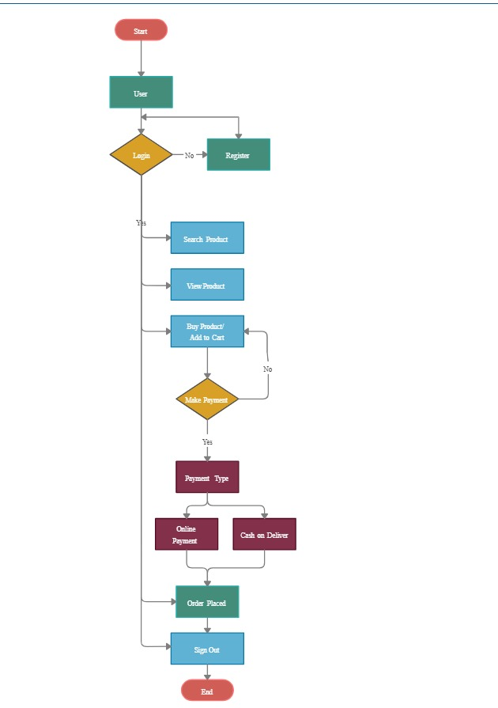

**9. Use case:**

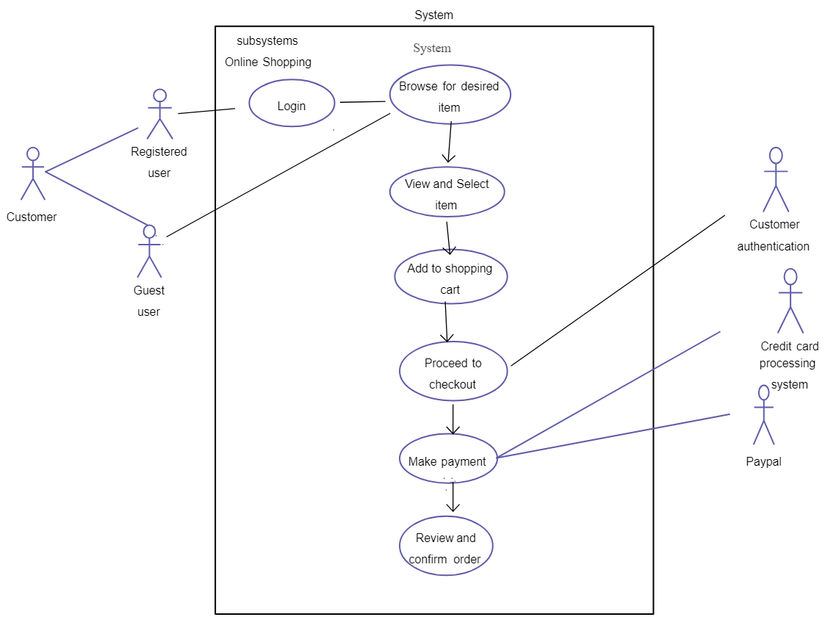

**10. Class Diagram:**

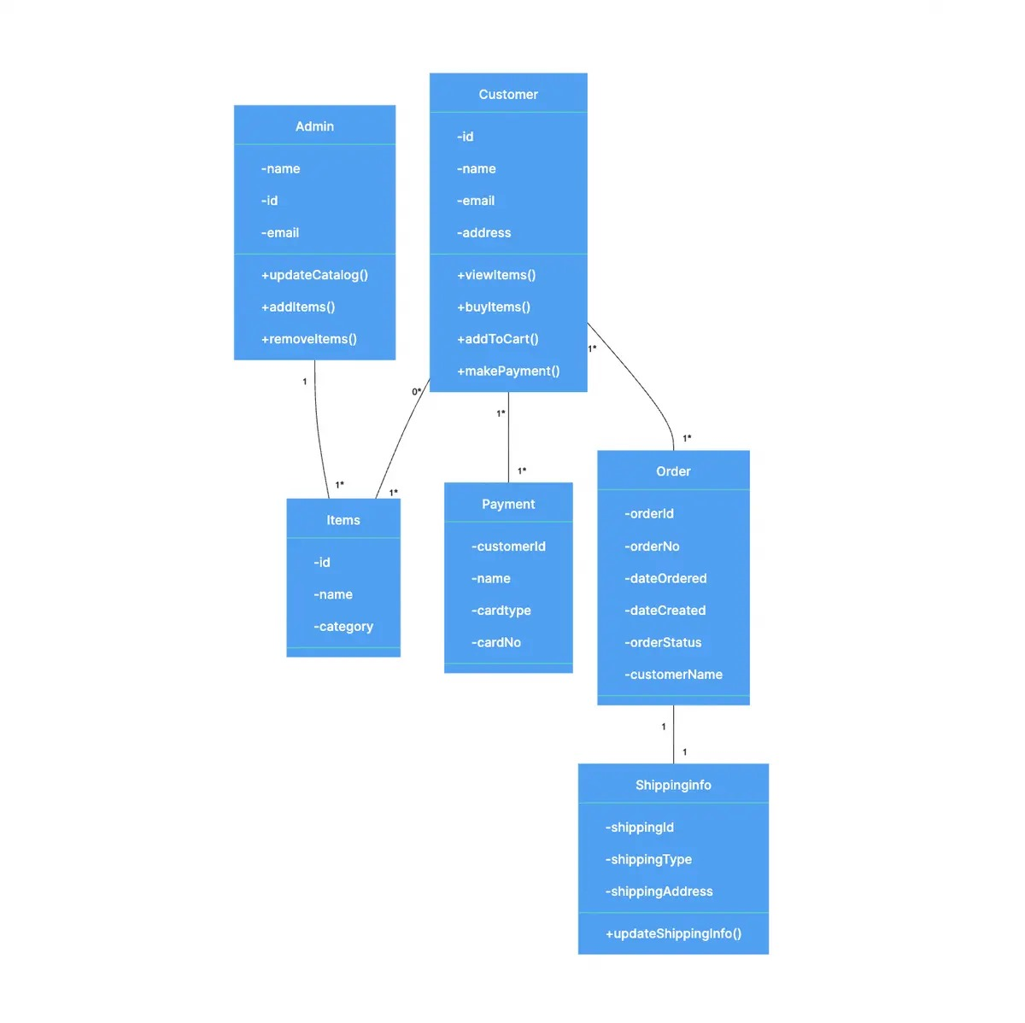

**11. Sequence Diagram:**

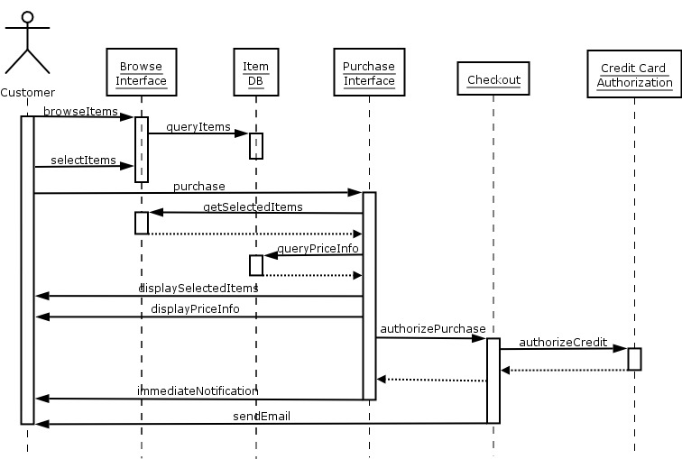

**12. Testcase:**

Testing an online shopping management system involves validating various functionalities to ensure they work as intended and meet user expectations. Below are some test cases categorized by different modules of the system:

**12.1 User Registration and Authentication:**

**Test case 1:**

Verify that users can register successfully with valid information (name, email, password, etc.).

**Test case 2:**

Attempt registration with invalid data (e.g., missing email, weak password) and ensure appropriate error messages are displayed.

**Test case 3:**

Test the email verification process by registering with a valid email and checking if the verification link works.

**Test case 4:**

Validate that users can log in with correct credentials and are redirected to the correct page after login.

**Test case 5:**

Test login with incorrect credentials and verify that the system displays an error message.

**12.2 Product Catalog Management:**

**Test case 6:**

Add a new product to the catalog with all required details (name, description, price, quantity, category, image) and verify it appears correctly.

**Test case 7:**

Edit an existing product and ensure the changes are reflected accurately in the catalog.

**Test case 8:**

Delete a product from the catalog and verify it is no longer displayed.

**Test case 9:**

Search for products by category, price range, brand, etc., and confirm that the search results are relevant.

**Test case 10:**

Verify that product availability status (in stock/out of stock) is displayed correctly on product pages.

**12.3 Shopping Cart and Checkout:**

**Test case 11:**

Add products to the shopping cart and verify they are displayed correctly with details like name, price, and quantity.

**Test case 12:**

Update quantities or remove items from the shopping cart and confirm the changes are reflected.

**Test case 13:**

Proceed to checkout, enter shipping and billing information, and confirm the order summary before finalizing the purchase.

**Test case 14:**

Test different payment methods (credit/debit card, PayPal, etc.) and verify successful payment processing.

**Test case 15:**

Test the checkout process with invalid or incomplete data and ensure appropriate error handling.

**12.4 Order Management:**

**Test case 16:**

Place an order as a registered user and verify that the order details (items, quantity, total amount) are accurate.

**Test case 17:**

Verify that users can view their order history, track shipments, and receive order confirmation emails.

**Test case 18:**

Test order cancellation and refund processes and confirm they are handled correctly.

**Test case 19:**

Check the system's response when attempting to place an order with out-of-stock items or insufficient inventory.

**12.5 User Account Management:**

**Test case 20:**

Update user profile information (name, email, address, etc.) and confirm the changes are saved correctly.

**Test case 21:**

Change password and verify that the new password works for login.

**Test case 22:**

Test the functionality to save favourite products, create Wishlist’s, and view personalized recommendations.

**Test case 23:**

Verify that users can unsubscribe from marketing communications or update their communication preferences.